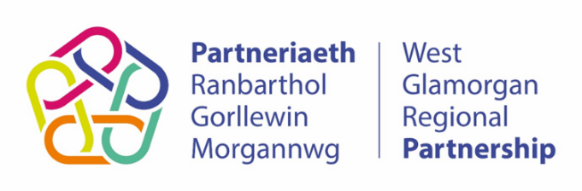
West Glamorgan Regional Partnership
Co-production Charter

 west.glamorgan@swansea.gov.uk Date: 07 December 2020
💻 www.westglamorgan.org.uk

Background

Following unprecedented times in health and social care in 2020, all the partners of the West Glamorgan Regional Partnership Board (WGRPB) wish to reaffirm their commitment to co-production. This document represents an agreement between all members of this board to commit to achieve our collective vision for embedding the principles of co-production across our work. This includes members of the board who represent Partnership Bodies committing to following the WGLAM Regional Co-production Framework for co-production in how they develop local co-production strategies and take meaningful action to embed co-production principles throughout their organisation.

OUR VISION - What do we want to achieve?

- We utilise co-production in an ambitious way as we transform our services to meet the needs of our population and its people, in a safe and sustainable way, so that people can enjoy long, healthy, active lives and enable those with long-term and life-limiting conditions to live well.
- We use the collective efforts and experiences of policy makers, commissioners, people who use services, carers, staff, staff representatives, third sector, business and local communities to work together co-productively, helping us to improve health and wellbeing outcomes for the population of West Glamorgan.
- We place people and carers at the centre of decision-making and connect people in co-productive networks so that we can develop, meaningfully influence, shape and participate as real partners in the commissioning, planning, delivery and evaluation of services.
- We consistently utilise co-productive principles and practices when we tackle health inequalities and discrimination.
- We openly recognise the need for demonstrable progressive realisation of co-production across all regional partnership programmes and in the development and review of regional strategies, frameworks and plans.

OUR PRINCIPLES - What do we mean by co production?

Co-production is an asset-based approach to public services that enables people providing and people receiving services to share power and responsibility, and to work together in equal, reciprocal and caring relationships. It creates opportunities for people to access support when they need it, and to contribute to social change.

More information about applying co-production can be found in the WGLAM Regional Co-production Toolkit for West Glamorgan.

Co-production is underpinned by five principles:

1. Value all participants and build on their strengths.
2. Develop networks of mutual support.
3. Do what matters for all the people involved.
4. Build relationships of trust; share power and responsibility.
5. People can be change makers, and organisations enable this.

To achieve transformational change, coproduction will ‘realise value through people’ so we can move us from a culture of ‘you said, we did’ to ‘we said, we did it together’.

OUR COMMITMENT - How will we know we are doing it, ascertain if we are progressing? What will be our key outcomes?

As a Board/Organisation, we are committed to the following strategic objectives:

- To co-productively develop and evaluate specific milestones for all programs to identify future co-production work.
- To increase, develop and implement co-production training which is developed together and delivered to all partners and organisations within the regional partnership.
- To creatively and actively engage our communities in health and social care services design and delivery.
- To increase the number of active participants in co-design and co-delivery of services.
- To co-design and develop the measurable and objective improvements in people and staff experience, care outcomes and the evidence of increased productivity across all services.
- To make changes that ensure the experience of the health and social care system is more ‘person centred’, and that contributions are recognised as enabling change so that health and wellbeing outcomes improve as a result.
- To make teams feel empowered; to make staff and people with lived experience feel valued; and to ensure that health and wellbeing outcomes for people with lived experience positively improve.
*This document will be reviewed on an annual basis by the co-production group*

Signed by:

Name
Title

