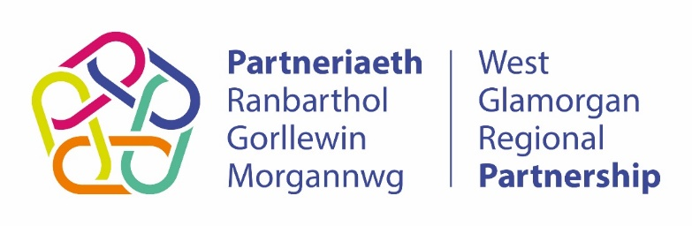

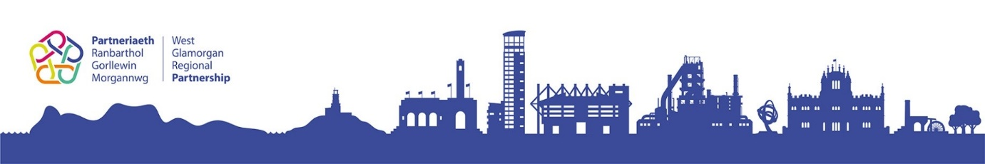

West Glamorgan
Regional Partnership

Co-Production
Toolkit

Region: West Glamorgan Regional Partnership

 01792 633 805

 west.glamorgan@swansea.gov.uk
One of the ten national design principles within ‘A Healthier Wales: our Plan for Health & Social Care’ is to drive change and transformation
Version Number: 0.4 Date Valid From: 07/12/2020 Approved by: Co-production Group
About this document

The West Glamorgan Co-production Toolkit provides information and guidance to support your organisation/board to work co-productively with people that use services or have used services and their carers being equal partners in the design, development, commissioning delivery, monitoring and review of services. Organisations should sign up to the WGLAM Co-production Charter before using this tool to ensure that there is a commitment from all staff that share an ethos of coproduction in their working practices.

Why co-produce?

Involving people that use services or have used services and their carers provides a different perspective, of lived experience of what works well and what does not work well for the target group. Co-production will enable an organisation/board to think differently; be challenged in a positive and productive way and be more creative and radical when transforming services. Working co-productively can increase job satisfaction and wellbeing for all partners involved. It will hopefully mean that the right services are commissioned from the outset and delivered effectively.

Co-production can make services ‘a better fit for the people that use them and more accessible. It can make an otherwise institutional situation feel more human’.

You can find out more information about co-production online (go to https://www.tnlcommunityfund.org.uk/insights/co-production as a good example).

Examples of current legislation supporting the benefits of working co-productively includes:
- Social Services and Wellbeing (Wales) Act (2014);
- Wellbeing of Future Generations (Wales) Act (2015);
- Regulation and Inspection of Social Care (Wales) Act (2016).

What is co-production?

Co-production is an asset-based approach to public services that enables people providing and people receiving services to share power and responsibility, and to work together in equal, reciprocal and caring relationships. It creates opportunities for people to access support when they need it, and to contribute to social change.

Coproduction is underpinned by five principles:
- Value all participants and build on their strengths.
- Develop networks of mutual support.
- Do what matters for all the people involved.
- Build relationships of trust; share power and responsibility.
- People can be change makers, and organisations enable this.

As demonstrated in Arnstein’s Ladder of Citizen Participation, coproduction is about ‘doing with’ people in an ‘equal and reciprocal partnership’:
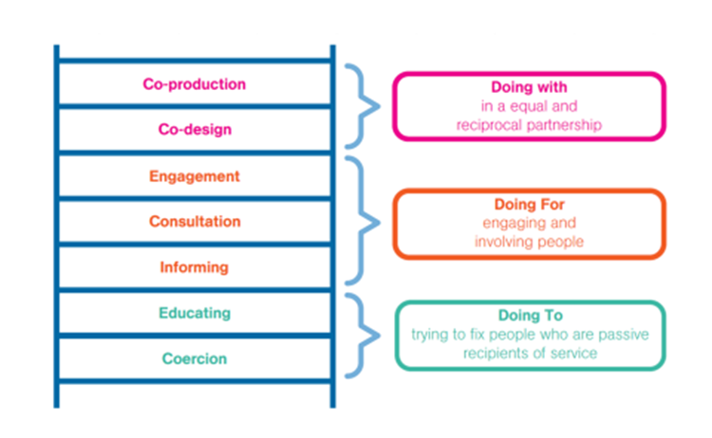
Fig. 1 – The Ladder of Citizen Representation

Representation is a way that is often used to engage and involve people, but is not co-production. Although Representatives are encouraged to have their say in meetings, they are often outnumbered by paid staff, their needs which allow them to participate are not always considered (e.g. they may not have a say in when and where the meetings take place) and they may not have a shared responsibility within the group (e.g. would not be offered a role such as Chair of the group).

You can find out more about co-production as well as representation in the WGLAM Co-production Framework which provides more details about embedding co-production principles in the West Glamorgan region.

Before you work through this Co-production Toolkit, you may find it useful to complete an Audit Tool to assess how your organisation is currently working co-productively, identifying strengths and areas for development. An effective tool is the Co-production and Involvement Audit.

A self-assessment tool for organisations developed by Co-Production Network for Wales is available online at https://info.copronet.wales/the-self-evaluation-audit-tool/ .

How to co-produce

Before starting, it is useful to consider:

- What is the project?
- Why is it happening? What needs to change?
- How much time do you have to do it? Do you need to challenge deadlines to work co-productively?
- Do you need support from the West Glamorgan Coproduction Group to get started?
- Can all parts of the project be co-produced? If not all, why not?
- Do you have support from management to co-produce this project?

We have included a useful table in Annex A with the key activities and questions that you can use to help you identify the appropriate approach to co-production, depending on the scenario you are working with (for example, a short Task & Finish group creating one simple document or a large, complex, high profile project working across partner organisations and regional areas to deliver many benefits for people and carers).

At the end of the project as a group, reflect on what went well and what was challenging. Did people feel meaningfully involved? Did the group have a good representation of diversity? What might you do differently next time? What might you do in the same way?

For further guidance and support please contact the West Glamorgan Coproduction Group through the group’s support officers based in both Swansea Council for Voluntary Service (SCVS) and Neath Port Talbot County Voluntary Service (NPTCVS).

Adrian Bailey (SCVS)  E-mail: Adrian_Bailey@scvs.org.uk | Ellis Owen (NPTCVS)  E-mail: EllisO@nptcvs.org.uk  Telephone: 01639 631246

Annex A

No. | Activity | Do you need to develop in this area?  If so, how will you do it?
1 | Does your organisation/board have a mechanism in place responsible for the development of services? If yes, does it have a clear Terms of Reference? Is coproduction referenced throughout it?
2 | Has your organisation/board actively sought people that use services or have used services and their carers to become involved?  - How have you promoted the work you are doing? (for example: partner organisations, local media, social media).  - Have you actively encouraged people to become involved?  - Have you provided a estimated time frame for completion of the project?  - Have you identified the likely extent of the time commitment required from participants and made this clear at the outset?
3 | Has your organisation/board considered equity to enable a diverse group of individuals are able to participate effectively? Things to consider may include:
If it is a physical meeting:
- Where the meeting is taking place?
- Is it far away for individuals?
- Is it on a public transport route?
- Are their car parking facilities and if so are these free?
- Is it a long walk from public transport stops/car park to the meeting venue?
- Is there an accessible lift in the building?
- Is there adequate space in the meeting room for wheelchairs and other equipment if needed?
- Do you need a hearing loop?
- Are individuals able to join remotely if they cannot physically attend?
- Are travel expenses reimbursed?
- Are appropriate breaks and refreshments provided?

If it is a virtual meeting?
- Do all participants have access to the technology needed?
- Can all participants access links for the virtual platform?

Other things to consider to increase participation:
- Timings of meetings and regular breaks.
- Have all participants received the information needed (e.g. agenda, minutes, reports) in good time to enable them to read through all the information before the meeting?
- Do you have representation of the people that are affected by the service e.g. children, older people?
- Do you have a good representation of diverse groups Black and Minority Ethnic groups, Lesbian, Gay, Bisexual, Transgender groups, Disability groups, Gender groups?
- Have participants received the information in a format they can access e.g. large print, easy read, first language?
- ‘Blended’ meetings which allow both attendees in person, and virtual attendees?

4 | Do you have an equal split of people that are using services or have used services and their carers (people that are volunteering their time) and paid staff?  The split should be equal or have slightly more people that are using services or have used services and carers.  Have you ensured that the members of staff representing your organisation have the appropriate decision making powers to enable decisions to be genuinely coproduced by the group?
5 | Think creatively of ways to break down the differences in power between paid staff and citizens  You might want to consider having an icebreaker in the first meeting to enable individuals to know each-other better on a personal level.  Does the language used in the meeting enable everyone to understand e.g. use of plain English, no jargon or acronyms?  Are paid staff dressed formally with work items such as lanyards? Are paid staff and citizens mixed in their seating arrangements?  Does the meeting need to be a traditional/formal meeting? Would the meeting held in a different way or setting enable all participants to feel more comfortable and increase their confidence to participate?
6 | Identifying Assets with the Group  Do all the members of the group know the skills, knowledge and experience of all the individuals in the group?  Do all members of the group have a shared knowledge of the existing services and resources? Are they all aware of the strengths in these existing resources and the challenges? Do they know what the gaps are?  Do members know each other’s links/networks/connections that can be utilised this work?
7 | Do all members of the group share the same vision?  Is there good communication within the group?  Are you making decisions and solving problems together as a group?  Is the Chair able to confidently and constructively handle differences of opinion or situations of conflict?
8 | Is the responsibility of the group shared amongst participants? For example, are roles of the group rotated e.g. Chair, minute taker? Is training offered to support individuals to take on these roles?  Are all individuals encouraged to participate?  Are all contributions acknowledged and valued by the group?  Do all members of the group have access to all information including the budget for a project?
9 | Are individuals in the group involved at every stage?  - Design  - Development  - Monitoring, review and evaluation  Does your project focus on creating good outcomes (the difference the project will make to someone’s life) rather than on outputs (how many times you did something)?
10 | Do you recognise the individuals that are volunteering their time? Can they be rewarded, for example, using time credits? Are their achievements and contributions celebrated?
11 | Do you need to challenge deadlines as a collective group to ensure that the work you are doing is true coproduction and not just tokenistic?

From the Wales Coproduction Network

