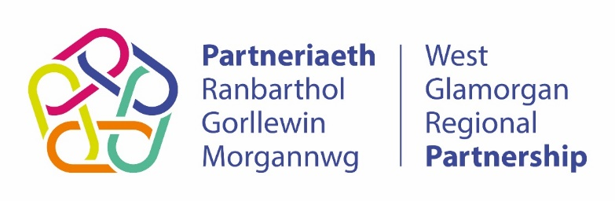

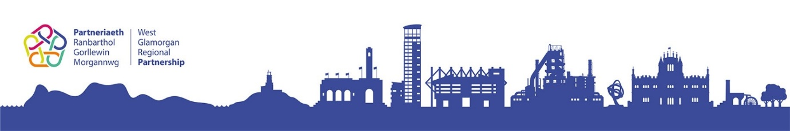

West Glamorgan

Regional
Co-production
Framework

Region: West Glamorgan Regional Partnership
 01792 633 805
 west.glamorgan@swansea.gov.uk

Version Number: 1.0 Date Valid From: 20/01/2021 Approved by: Recovery Board
Introduction

The West Glamorgan Regional Partnership is a strategic mechanism for co-ordinating a collection of programmes, projects and workstreams that partners (the Health Board, Local Authorities, Third Sector and others) have identified as common priorities for health and social care transformation. Delivery of a complex portfolio of work requires consistent instructions and guidance for those involved in the delivery of change, to establish how things should be done.
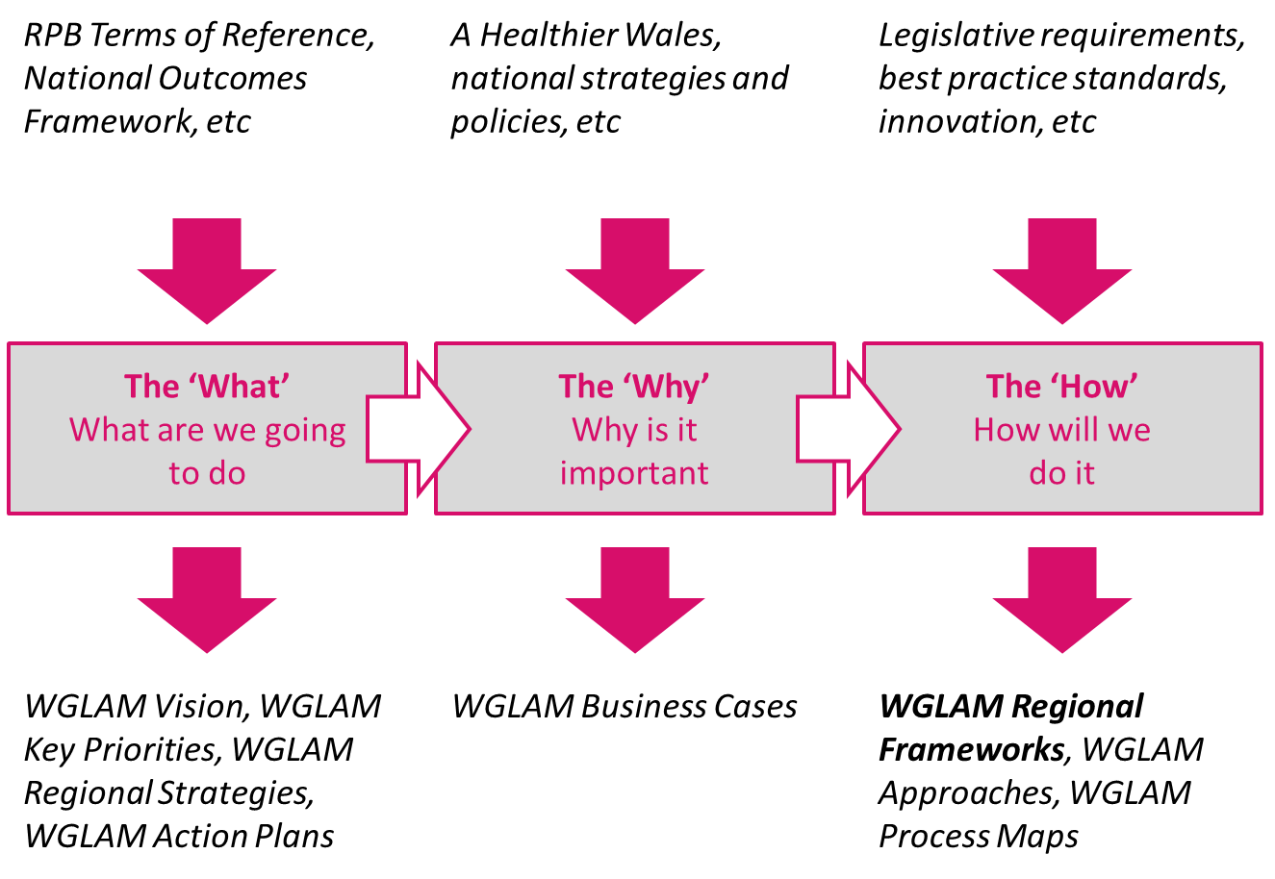
Fig. 1 – The What, Why and How of regional partnership working
This regional framework has been created by the regional Co-production Group, which includes representatives of all partner organisations as well as people and carers representatives. It will inform how co-production will be embedded across the partnership including how the voice of our people will form the core of transformation activities in health and social care.
Please note that additional materials are highlighted throughout this document, some of which may be under development at this time.

Contents

Section 1 – Context 4
Background 4
Definitions 5
Alignment to Regional Partnership 7
Section 2 – Principles 9
Challenges 9
Opportunities 10
Lessons 10
Outcomes 13
Principles 14
Section 3 – Approaches 16
Strategic Approach 16
Representative Role 20
Citizens Forum 21
Co-production Group 23
Support for Co-production 24
Co-production Documents 25
Focused Approaches 25
Monitoring & Reporting 26
Implementation 27
Appendices 28
A – Action Plan 28
B – Glossary of Terms 30

Section 1 – Context

Background

The idea of co-production originated in the 1970s from studies of the relationships between police officers who walked their beats on foot to those who patrolled in vehicles. The study by the Indiana University discovered that crime rates improved when police officers developed relationships with local communities and those people played a crucial role in providing a voice to preventing and solving crimes.
The concept became applied wider including health and social care environments. It became more widespread during the early 21st Century especially in relation to disability and mental health movements; it is now a fundamental aspect of health and social care transformation.
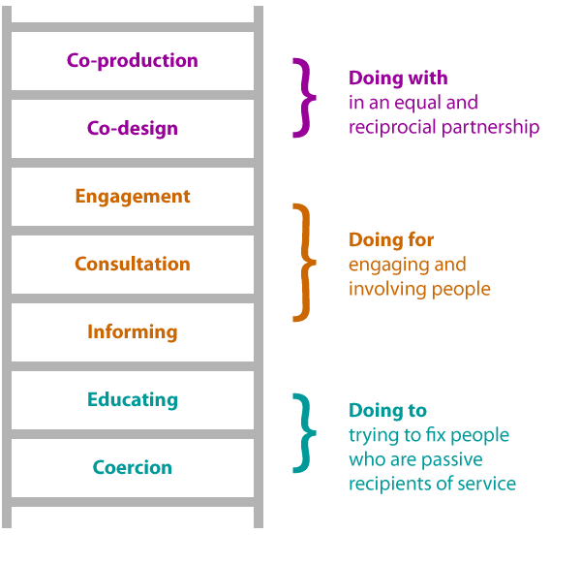
The idea evolved with the development of the Ladder of Citizen Participation concept, which was originally developed by Sherry Arnstein in 1969. It mapped the levels of participation by people in the decisions and design of services. In recent times, this has been adapted to demonstrate the Ladder of Co-production and show how the more involved people are in these important activities and decisions, the more can be achieved.

Fig.2 – The Ladder of Co-production

Co-production is one of the main principles of the Social Services and Well-being (Wales) Act 2014. Section 162 of the Act requires local authorities to make arrangements to promote co-operation in relation to the exercise of all their functions relating to people with needs for care and support. The Act prioritises engagement with people, ensuring voice and control for people who need care and support, and carers who need support. More information on the Act is available here.

The West Glamorgan Regional Partnership – and prior to April 2019, the Western Bay Regional Partnership – has always placed a great deal of importance in the principle of co-production. The regional transformation of health and social care could not be successful without the involvement of people who share their insights, stories and experience in the design of services and implementation of the transformation work.

This regional framework provides all partner organisations, stakeholders and representatives – including children and young people, individuals and carers – with the structures and approach to embedding co-production in all we do across the regional partnership.

Definitions

Co-production is an asset-based approach to public services that enables people providing and people receiving services to share power and responsibility, and to work together in equal, reciprocal and caring relationships. It creates opportunities for people to access support when they need it, and to contribute to social change.
Co-production is underpinned by five principles:
- Value all participants and build on their strengths.
- Develop networks of mutual support.
- Do what matters for all the people involved.
- Build relationships of trust; share power and responsibility.
- People can be change makers, and organisations enable this.

Here are some other important definitions relating to co-production:

- People – this term broadly refers to any member of the population, regardless of age, gender or any other characteristic. In our context, it mostly relates to people who use health and social care services (i.e. Service Users) but it is not limited to this distinction.
Note: The term “citizen” is sometimes used but this term can be limited to people who actually live in an area; this can miss out key groups of people such as asylum seekers, who are also using these services.

- Service User – some people will use particular services depending on their needs (for example, someone with mental health conditions may use certain mental health support services). These people bring specific “lived experience” to the transformation of these services through co-production.

- Carer – there are both paid carers (people employed to provide care and support) and unpaid carers (people who provide care and support outside of a profession e.g. for family members). We generally refer to unpaid carers, who are often representing the needs of the person they care for as well as their own needs (they also can access services to support their own health and wellbeing).

- Professional – this is a generic and very broad term for people employed to work in health and social care settings and organisations. It includes members of the third sector and other paid employees.

A glossary of the terms referenced in this document is at Appendix B.

Alignment to Regional Partnership

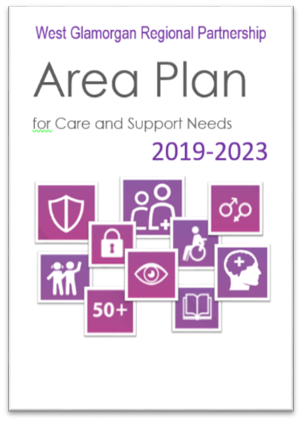
Embedding co-production across the regional partnership will require integration across our partners including the regional Health Board and Local Authorities. We want to enable all people (individuals and organisations) to follow the same path in how they approach working in a co-productive manner.
The vision, aims and priorities of the partnership is defined in our West Glamorgan Regional Partnership Area Plan 2019-2023 document. For further information please go to www.westglamorgan.org.uk .
As the work of the partnership focuses so much on the services, products and themes that are relevant to the people and carers of West Glamorgan, it is important their voice is heard when we are developing these things.
This framework is one of a number of similar guidance documents which explains how an important function of the partnership works. It will describe how we make co-production work in the context of the regional partnership. Each framework provides details about “how” we approach an aspect of our regional transformation; there are also a number of strategy documents that provide details about the “what” in terms of our vision, values, outcomes and objectives under a specific theme such as Carers, Digital, Housing, etc.

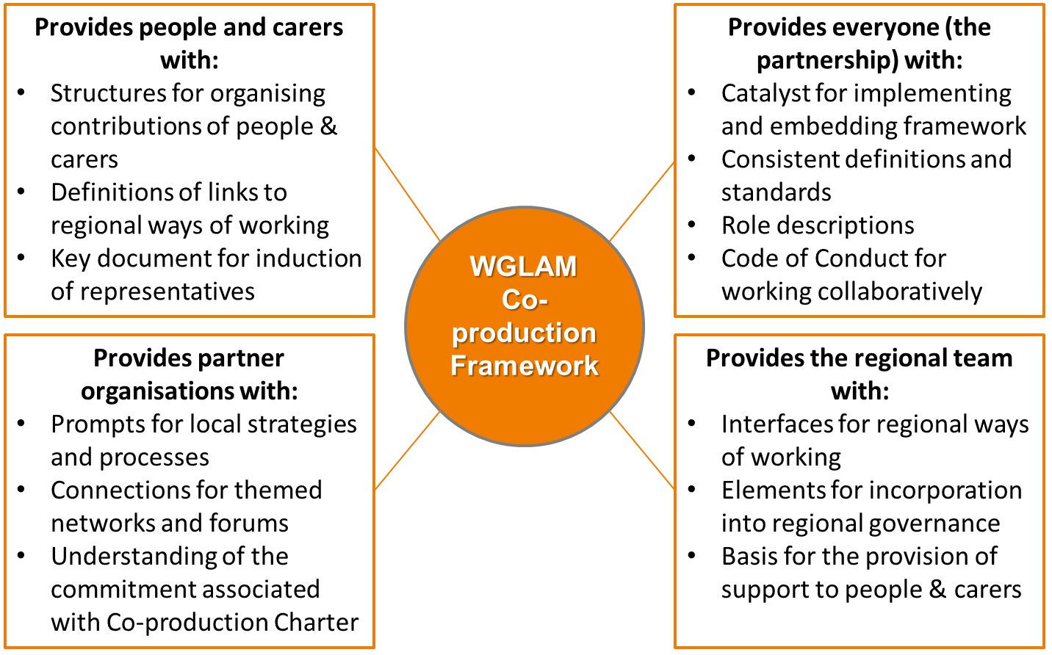

Fig. 3 – Benefits of Regional Co-production Framework

Section 2 – Principles

Challenges

Communicate expectations – when we have designed services in the past, it has been important to understand the expectations of the service from the people who use it. There are currently gaps in our approach involving communicating and working with people and carers.
Increase citizen representation – The regional partnership is extensive and complex in the scope of change it has to deliver. To do so effectively and consistently, we need representation of people and carers in the appropriate areas and at the right levels of the regional governance structure (where citizens are considered as equal partners).
Embed in partner organisations – partnership working involves organisations from health and social care with existing ways of working. Their unique approaches have to align so as to work collaboratively if we are to embed co-production at a regional level.
Driven by cultural change – to achieve this ambition to embed co-production across all partners, we know there are elements of cultural change that need to be owned and driven by the regional partners themselves. This would make co-production an ethos that is inherent in everything we all do.
When to use co-production – given the scope and complexity of the regional partnership, it can be important to decide on when and when not to use co-productive techniques. Too much application of these techniques can stretch resources, extend delivery timescales, increase costs and potentially complicate regional issues.
Representation is not co-production – there is an inconsistent understanding in the difference between representation and co-production, which means that sometimes the wrong approach is used.

Opportunities

Better outcomes for people – co-production benefits our population in terms of delivering better outcomes. With the ‘voice’ of people and carers informing the development of our services, the results can include improvements in measurable outcomes and benefits for service users.
More effective professional roles – a consistent framework for co-production will benefit professionals by helping them to be more effective in their roles and deliver better job satisfaction.
Higher profile of people – a big part of this change is raising the importance of the ‘voice’ of people and changing governance arrangements to provide a higher profile of our people and carers.
Better quality services –organisations who provide services to the people of our region can benefit from more efficient and effective services, as a result of co-production in service design and service development. This is driven by a greater understanding of the roles of people and carers in helping to make health and social care services better.
Raising the profile of co-production – having operated without a framework to this point, we have an opportunity to use this document as a way of raising awareness and promotion of co-production. This can help us to sell the benefits of co-production in a regional model as well as selling the positive outcomes it can provide.

Lessons

Below are some examples of lessons learned about co-production which inform our regional framework:
- Co-production Concept – there are lots of great examples and case studies about how to do co-production well. The Co-production Network for Wales [see here] has great resources and information about the concept and application of co-production principles including the ‘Seeing is Believing’ Report.
- Co-production in Local Authorities – the Local Government Association [see here] provides some advice and guidance on co-production that is specific to local authorities.
- Co-production in Health – The 1000 Lives report [see here] sets out why co-producing services is important for achieving the right health outcomes and the steps in co-producing health services.
- Co-production in Third Sector - Care Council for Wales [see here] highlight the important role of social enterprises, co-operatives, user-led services and third sector organisations in co-production.
- Co-production and commissioning – embedding co-production in how we plan and commission services for people and carers is explored further by the Care Council for Wales [see here].
- Co-production and evaluation – taking a co-productive approach to evaluation activities (e.g. when a project has been completed, evaluating how successful it has been in terms of delivering outcomes) is a gap in our current regional governance.
- Co-production with Children and Young People – taking additional action that will support children and young people to get involved in co-production safely and effectively, in line with strategic direction provided by the Children’s Commissioner for Wales.
There are a number of important theories, models and principles that apply to our understanding and application of co-production including:
Strength-based Asset Development – this is a generic term for an approach that puts our strengths at the centre of our efforts to make change happen. In the context of this framework, this relates to building on the strengths of our region and its communities, as well as the individual strengths, knowledge and experience of people (both volunteers and professionals).
PANEL Principles – A human-rights based approach that focuses on the following principles as people’s human rights adopted as the core of our practices and policies:
Participation | Everyone has the right to participate in decisions which affect their lives. Participation must be active, free, meaningful and give attention to issues of accessibility, including access to information in a form and a language which can be understood.
Accountability | Everyone with a duty to protect rights is held accountable; this requires effective monitoring & remedies. For accountability to be effective, there must be appropriate laws, policies, institutions, administrative procedures and mechanisms of redress in order to secure human rights.
Non-discrimination | All forms of discrimination in the realisation of rights must be prohibited, prevented & eliminated.
Empowerment | Everyone should know their rights and be supported to participate in decision making, and to claim their rights where necessary.
Legality | Public authorities should expressly apply the Human Rights Act and make linkages with international & regional human rights standards.

Following on from the COVID-19 pandemic and the impacts this had on our region in 2020, the following important lessons were also identified which relate to co-production in general:
- Communities play an important role in our health and wellbeing, as demonstrated during the pandemic when community volunteers stepped up to provide vital support to the most vulnerable members of our communities – this suggests that communities will be vital in stabilising our region after the pandemic;
- Communications is a continuing theme when considering the lessons learned during the pandemic, in terms of the importance of clear and consistent messages that are easily accessible, understandable and meaningful to people and organisations;
- Digital technologies have played an important role in the pandemic response and helped people to stay in touch but it has also highlighted issues that exist that prevent people from using digital means to interact with services;
- What happens in the longer term after the COVID-19 pandemic remains uncertain but this presents an opportunity to consider what new ideas, models and ways of working we want to embed in the “new normal” based on our experiences during the pandemic.

Outcomes

When you consider the challenges, opportunities and lessons highlighted above, we can start to identify the outcomes that we wish to see delivered by our regional co-production efforts:
Outcomes
Title | Description | Measures
Evidence of co-production principles embedded at strategic decision-making | We are constantly and consistently providing evidence about co-production works within the RPB and in support of strategic-levels of decision-making. This evidence may include demonstrations of how key decisions are made with input from all parties. | Evaluation of strategic decisions with evidence of co-production principles being applied.
Increased numbers of service users involved in regional co-production | There are more people and carers undertaking Representative roles within the West Glamorgan Regional Partnership. Each Representative has undergone the right induction and training to support them to be effective Representatives. | Numbers of Representatives mapped against roles in the West Glamorgan governance structure.
All regional partners committed to embedding co-production principles | Each partner organisation represented on the Regional Partnership Board has signed up to the WGLAM Co-production Charter and agreed to implement the changes necessary to ensure that co-production principles are embedded throughout their organisation. | Formal signatures from organisation leaders to the co-produced WGLAM Co-production Charter.
Increased number of ‘lived experience’ case studies used to inform co-production | With more people and carers engaged with the transformation journey in West Glamorgan, there will be an increase in the number of real life experiences identified and used as part of co-production and co-design activities. | Numbers of documented case studies from West Glamorgan citizens and carers.

Using outcomes as an indicator for how successful we are in embedding co-production principles across the region helps us to provide evidence of what is being done differently and the positive impact this has on our people and carers. Many of these outcomes are intrinsically linked to the wider work of the regional partnership and specific activities with the transformation programmes. Our main aim – to embed co-production principles in all that we do – can be evidenced by how successful the partnership can be if co-production is used effectively and consistently.

Principles

Based on the challenges, opportunities and lessons we identified above, we have created the following principles for our co-production framework.
Principles
Title | Description
Confidential | We have the right processes and safeguarding in place to protect and support people and carers in making their contributions to our regional co-production activities.
Equality | We have a co-production system that places equal representation on people, carers and partner organisations, building proactive relationships between everyone, where all contributions are valued.
Equity | We have greater use of power and the resources available to support co-production that balances people, carers and partner organisations.
Evidenced | We empower people and carers to use their stories and lived experiences to make a valuable contribution at the core of regional transformation.
Inclusive | We take action that makes people and carers feel respected and valued as part of the partnership; this includes additional measures to make it easier for them to make contributions.
Rights Driven | We focus our agendas, actions and strategies on the rights of people and carers, placing the voice of our population at the centre of our transformation programmes. Respecting their rights enables us to meet their needs more effectively.
Visible | We communicate regularly, clearly and inclusively on the decisions and actions of the regional partnership, using regional tools and forums to promote our co-production activities.

Section 3 – Approaches

Strategic Approach

Regional Co-production in Governance Model
In West Glamorgan, we want our people and carers to be supported in the way in which they contribute to our partnership. This strategic approach puts in place the structures and processes to enable that to happen effectively.
The diagram illustrates how people and carers are represented through the governance model of the Regional Partnership:
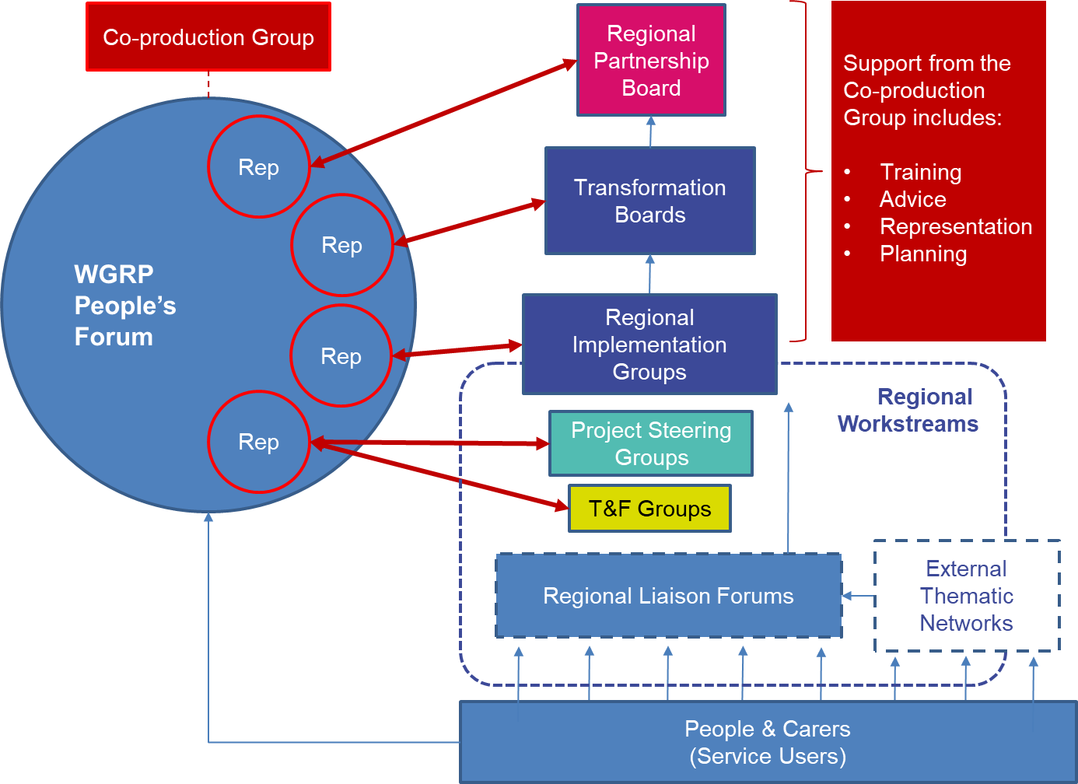
Fig. 4 – WGRP Representatives Governance Model
A few brief points to note about this model:
- People and carers (which may also be referred to as service users or patients in relation to health services) can cover the whole population of the West Glamorgan region, which can be focused onto local areas or communities.
- In relation to key themes across health and social care (for example, carers) we want to bring together a diverse range of people and carers across our regional population with a shared interest in this theme through our Regional Liaison Forums. These forums are specific to those themes (not all themes will require a forum to be established) and may include links to other related networks based on that theme (for example, the Swansea Parent Carers Forum).
- Through the Regional Liaison Forums, we identify people and carers who have a specific interest in supporting an element of our transformation portfolio. Following the example with carers, we may identify carers who can undertake the role of Representative.
- Some Representatives will be involved in short term initiatives, such as Task and Finish [T&F] Groups or Project Steering Groups. This will require a limited involvement from people and carers over a short period of time, where specific experience or knowledge may be beneficial. Once the T&F Group or project is complete, individuals do not need to continue their Representative role.
- Some Representatives will be involved in roles that align with the West Glamorgan Regional Partnership governance. This will be as members of the Regional Sub Groups (e.g. Carers Partnership Board), Transformation Boards (e.g. Integrated Transformation Board) or the Regional Partnership Board. Within the Terms of Reference for each of these groups, the role of these representatives (what they will be expected to do) is made clearer. These individuals may be expected to perform this role over a longer period of time for consistency.
- All of these Representatives come together on a regular basis through the People’s Forum which is an opportunity for sharing knowledge, experience and progress updates on the work across the partnership.
- Supporting this whole process – including individuals in the role of Representatives and the People’s Forum as a community group – is the Co-production Group. They are responsible for driving the actions to embed co-production across the partnership.
Applying Co-production Principles
While the diagram above shows how the principles of co-production can be embedded throughout the partnership, the application of these principles will depend upon specific situations. Co-production is not a “one size fits all” methodology and therefore it is important that this framework the different ways to apply co-production depending on the scenario.

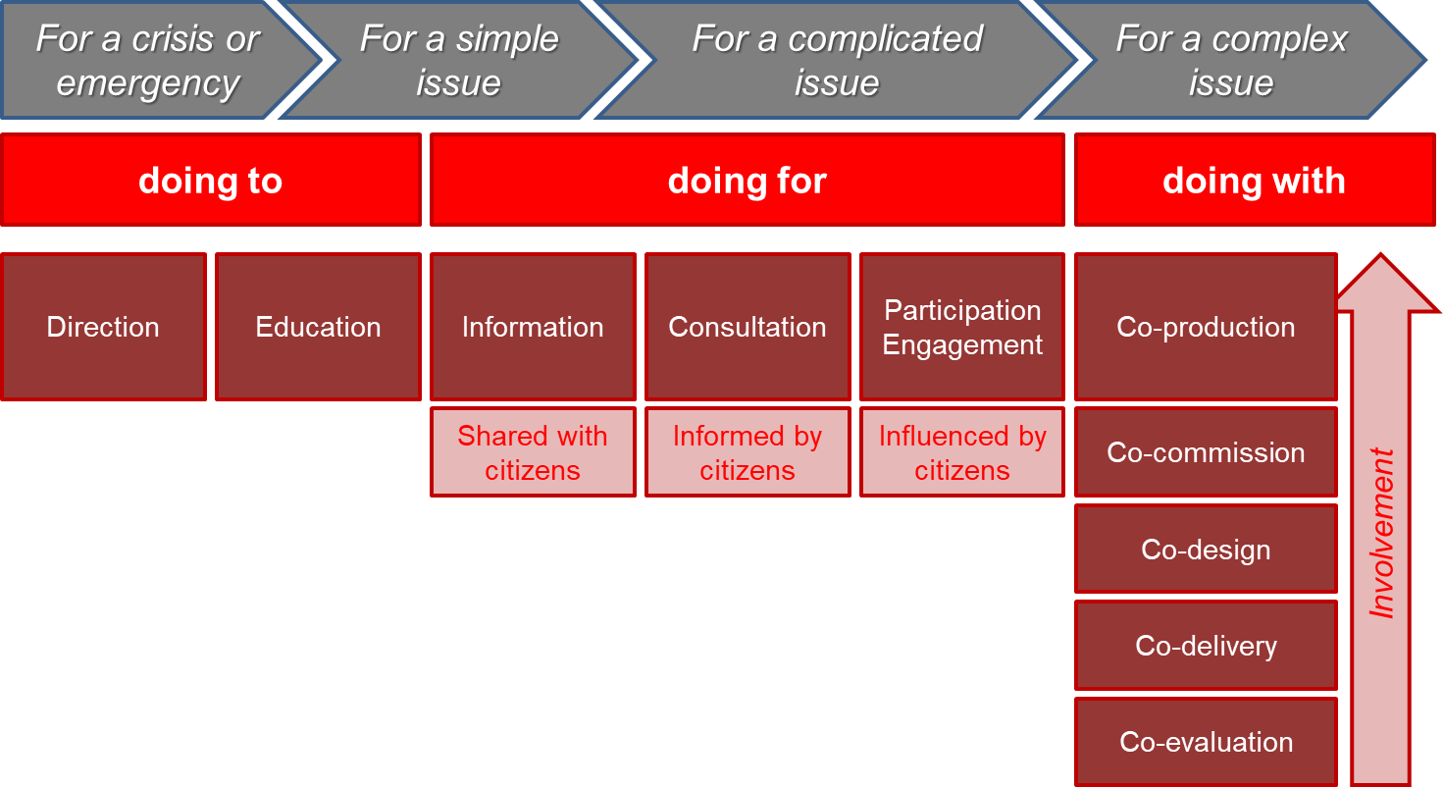
Fig. 5 – Application of Co-production Model
This shows how different scenarios can inform how we undertake co-production activities. Depending on the scenario, it may be more appropriate to take an approach that is more at one end of this scale than the other. This has been particularly relevant through the COVID-19 pandemic, which has informed this approach.
There are case studies to support each of these scenarios and the table below illustrates some of these potential scenarios:
Scenario | Application of Co-production
The COVID-19 pandemic has identified a major issue with a health board process for patients. The process needs to change urgently to ease the pressure on hospital resources. The changes are expected to be temporary to deal with the pandemic. | Doing to  A time-bound activity by the health board to change its process is to be completed as a matter of urgency. Where there is no scope to improve services in the long term, patients are informed of the changes once they have been approved and implemented.
A change in legislation is enforcing local authorities to make amendments to an existing form that makes it compliant with the legislation. There is no scope to challenge the changes but there is no substantial impact on people and carers apart from capturing the information. A deadline by which the changes must be completed is enforced. | Doing for  Representatives of people and carers are made aware of the changes in legislation and the impact on the form. The amended form is shared with citizens and carers through the right forums and channels. Where the change may have wider impacts (such as easy read versions of the form guidance) citizens are consulted in the changes to the guidance. Progress of the project is reported regularly through the Peoples Forum.
A new regional service which combines health and social care processes is being developed as part of a new five-year strategy. The service is based on a new mandate from Welsh Government and is intended to support communities in meeting local needs of citizens. | Doing with  Principles of collaboration are embedded in the project from the beginning. The new service is co-designed within partner organisations and representatives of citizens and carers. Parts of the service which are outsourced undergo a suitable co-commissioning approach to find a delivery partner. Representatives sit on Task & Finish Groups to develop key outputs such as guidance documents for the public. Insight on the products is also sought from wider communities through surveys and workshops.

The key to our strategic approach is working collaboratively to determine the most appropriate response to applying co-production principles in difference scenarios.

Representative Role

This role is an important part of how the regional partnership works, as it allows people and carers to have an equal level of responsibility in the co-production of services, activities and regional transformation programmes and projects. A more detailed breakdown of this role can be found in the WGLAM People’s Representative Role Description.

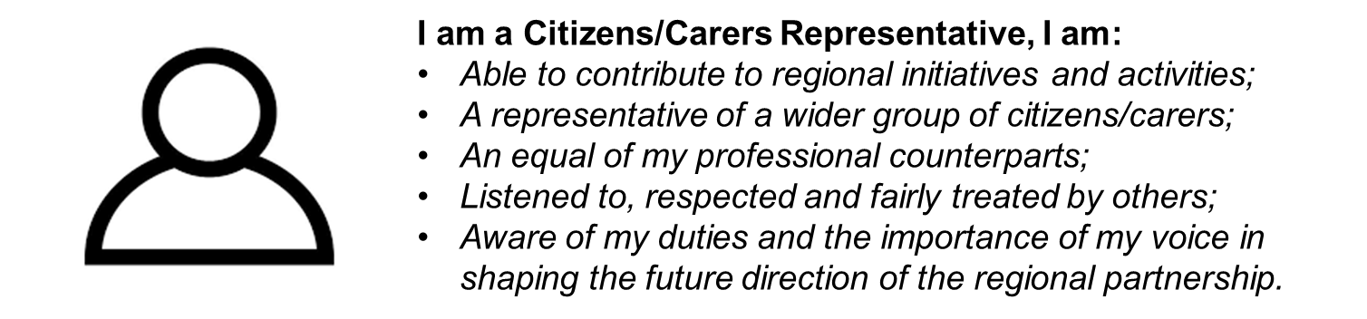
Fig. 6 – The Role of the Representative

This approach of using people and carers to “represent” the wider views of the population needs a large, diverse group of representatives to cover all of the work of the regional partnership. The Co-production Group will help the identification, appointment, training and support of Representatives by:
- Recruitment – to identify potential Representatives through various channels of engagement with people and carers, including through partner organisations. This includes a simple process for speaking with members of the wider population, to help them to understand the role.
- Induction – to provide all new Representatives with the WGLAM Co-production Induction Pack to provide an overview of the regional partnership, the organisations involved, our approach to co-production and the key elements of the transformation portfolio. This framework document is an important part of that Induction Pack.
- Skills Audit – to help Representatives to understand what skills, knowledge and experiences that can bring to the regional partnership through a simple, informal review. This helps us to find the right match in terms of what role they can play within the regional partnership. It also helps to understand what skills our Representatives wish to improve further for their own personal development.
- Training – to provide training (both formal classroom-based training and informal knowledge sharing opportunities) to support our Representatives and help them to develop their skills.
- Engagement – to make sure that there is regular communications and engagement with Representatives, both in the specifics of their assigned role and as part of the Co-production Group community. This will be informed by the WGLAM Co-production Communication Strategy which highlights the approaches and channels available to make this happen (e.g. the ‘People working with the West Glamorgan Regional Partnership’ Facebook Group).

People’s Forum

The regional partnership consists of a large, complex portfolio of programmes and projects, with different types of initiatives, various governing boards/groups and lots of roles for Representatives.
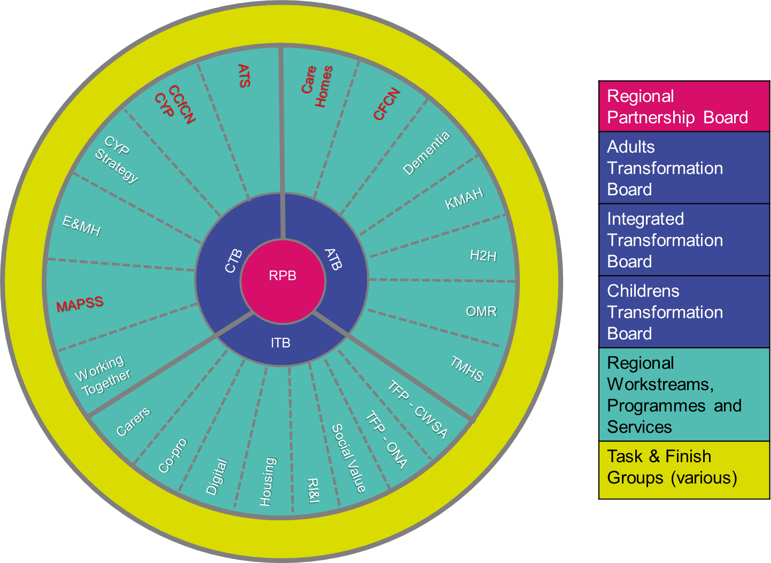
Fig. 7 – Simple overview of WGRP structure (subject to change)
Note: Further explanation of the programmes and the latest governance structures are available from the WGLAM Transformation Managers.
There is a potential risk that Representatives may feel isolated or unaware of what is going on across the partnership that may affect the role that they are undertaking.
To provide a peer support function to Representatives, the Co-production Group co-ordinate a regular meeting of all the Representatives known as the People’s Forum. This brings all of the Representatives together (including invited guests from partner organisations and the West Glamorgan Transformation Team) to:
- Build relationships between Representatives;
- Participate in group activities and events;
- Share personal stories and experiences;
- Share local, national and international news/developments;
- Update on progress of regional work;
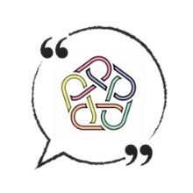
- Support each other as a unified community.
The People’s Forum is also an opportunity for people and carers to play a more active part in the regional parthership. This is an open and inclusive forum where anybody can attend to find out more about health and social care transformation across the region.

Co-production Group

The Co-production Group is Group is a resource of assets. The people, carers and professionals involved (including staff from the Health Board and Local Authorities) offer a variety of different skills, knowledge and experience. The group provides a collective voice that offers positive solutions to issues within existing and potential projects and services.
It is important to note that the membership of the Co-production Group is not just people and carers, it includes representation from all partners in WGRP. This is important because the essence of co-production is that all views are considered and treated equally so this principle is inherent within the group itself. The Chair of this group will be a Representative elected to undertake this role for an agreed period of time.
What We Do
- Raise the profile of co-production across West Glamorgan (which includes Swansea, Neath and Port Talbot).
- Provide mentoring support and guidance to anyone within the West Glamorgan area wanting to co-produce projects and services.
- Provide an opportunity for people (including carers) to get involved in co-production opportunities.
- Provide quality control within the designing, development and delivery of co-produced projects and services.
- Collectively flag potential areas that need attention and would benefit from a co-productive approach.

Further information is available in the WGLAM Co-production Group Terms of Reference document.

Support for Co-production

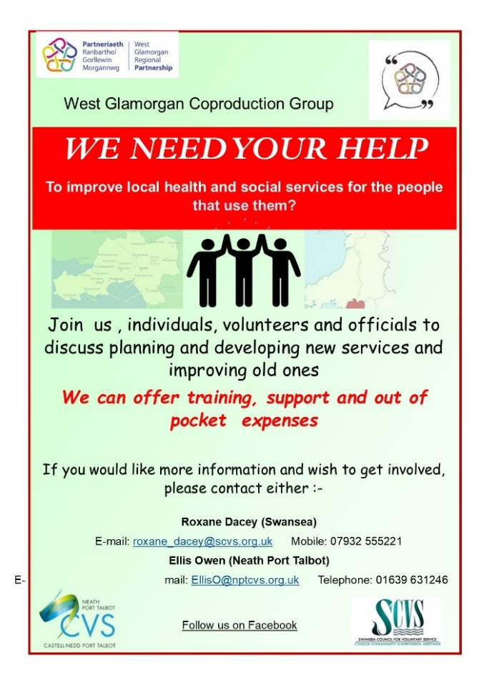
The work of the Co-production Group is supported by two Co-production Development Officers, one based in Swansea Council for Voluntary Services [SCVS] and one in Neath Port Talbot County Voluntary Council [NPTCVS]. Their role is to work collaboratively with Representatives to provide the support, advice and guidance that will enable the Co-production Group (and the People’s Forum) to function effectively as part of the governance of the regional partnership. This includes providing direct support to Representatives such as access to equipment like laptop computers and co-ordinating meetings and events.
Fig. 8 – Representative Recruitment Poster

The West Glamorgan Transformation Team also provide support to the Co-production Group. Specific functions of the team – such as communications, finance and reporting – are extended to support the work of the co-production community across the regional partnership.
Much of co-production support such as training is also delivered co-productively. This makes it everyone’s responsibility to promote and teach others about our co-production principles. There is also support for Representatives in the form of peer-to-peer mentoring and national networks such as Co-pro Wales.

Co-production Documents

To enable us to embed co-production and support Representatives to perform these important roles across our transformation programmes, as well as supporting partner organisations to work in a co-productive manner, we have a number of documents to help us make this happen:
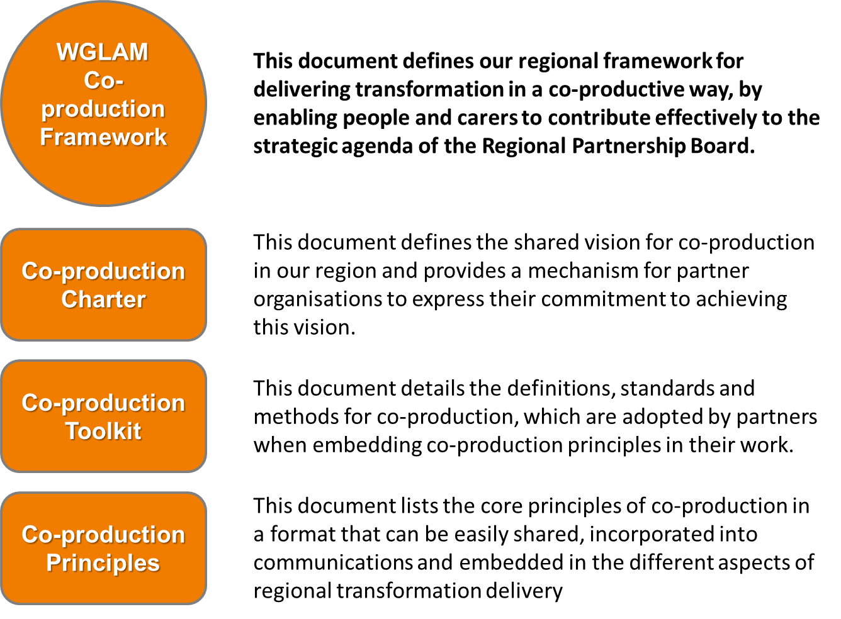
Fig. 9 – Key Co-production Documents
Other documents, templates and information will be made available to support the work of the Co-production Group and the Representatives (including information about the partnership itself).

Focused Approaches

Below are the more detailed approaches that we will use in delivering this framework; they are important parts of the overall approach and they ensure we remain consistent in the detail of our strategic methodology.
No. | Approach | Process
1 | Confirming commitment of partner organisations | How to get partner organisations to sign the WGLAM Co-production Charter and agree the actions required to embed co-production principles across their business.
2 | Raising awareness of Co-production | How to conduct awareness-raising activities across the West Glamorgan region to inform people and carers about the importance of co-production in health and social care.
3 | Recruiting new Representatives | How to identify and recruit new Representatives from interested people, carers and CYP in West Glamorgan including undertaking induction activities.

An overview of each process is included in the WGLAM Process Maps document.

Monitoring & Reporting

As our regional work progresses and our maturity as a partnership with co-production at its core improves, we will continue to monitor and review our progress against this framework. To do this, we will:
- WGRP Annual Review Report – we will make contributions to the Annual Review about how co-production is being embedded and used across the partnership, with reference to important milestones in our Action Plan and contributions from Co-production Group members;
- Highlight Report – we will produce a Highlight Report to the Integrated Transformation Board to demonstrate our progress in delivery our actions and escalation of any co-production related issues;
- Other Regional Reports – where it is appropriate, Representatives may make contributions to specific regional reports and other reports on behalf of the regional partnership (for example, Annual Carers Partnership Report).

Open and easily accessible communications will allow us to report effectively what we have done including our successes and lessons learned. The regional partnership will use Microsoft Teams as the preferred platform for storing and sharing our reports, documents and dashboards.

Implementation

This framework introduces the concepts and functions we want to implement within the regional partnership, which will make co-production an important central element of our transformation agenda. Together, we all need to be innovative and empowered to deliver change at pace in order to achieve our collective ambitions for co-production in West Glamorgan. Implementing the framework will take time and effort from all parties and the Action Plan at Appendix A sets out our key activities to achieve our aims and outcomes stated within this document.

Appendices

A – Action Plan

Activity | Description | Owner | Deadline
Develop a Co-production Charter | To co-produce a charter which signifies the commitment of an regional partner to embedding the principles of co-production throughout its organisation | Co-production Group | October 2020
Undertake a Skills Audit of Representatives | To undertake an assessment of the skills, knowledge and capabilities of the individuals who undertake the role of Representative | Co-production Group | March 2021
Define Terms of Reference for the Co-production Group | To create, review and publish a Terms of Reference for the Co-production Group that establishes the structure, membership and controls for the group | Co-production Group | April 2020
Define Terms of Reference for the Citizens Forum | To create, review and publish a Terms of Reference for the Citizens Forum that establishes the structure, membership and controls for the group | Co-production Group | December 2020
Run a Recruitment Campaign for new Representatives | To conduct a public campaign to attract and recruit people to the role of Representative across the various boards, groups and activities of the regional partnership | Co-production Group | January 2021
Plan and deliver a Training Programme for Co-production | To create, schedule and deliver a programme of training activities that will result in increased awareness and application of co-production principles | Co-production Group | March 2021
Develop an Induction Pack for supporting new Representatives | To create, review and publish an Induction Pack which is used to onboard new individuals to the role of Representative | Co-production Group | November 2020
Collate sources of research, innovation and improvement relating to co-production | To identify, capture and share details about sources of co-production related research, innovation and improvement activities with the West Glamorgan RI&I Co-ordination Team and other stakeholders | West Glamorgan RI&I Team | October 2020
Launch the WGRP People’s Forum | To formally launch the new People’s Forum through promotion and awareness campaign activities | Co-production Group | January 2021
Launch the WGRP Co-production Framework | To formally launch the new Co-production Framework through promotion and awareness campaign activities | Co-production Group | February 2021

B – Glossary of Terms

ATB | Adults Transformation Board
CTB | Children & Young People (CYP) Transformation Board
ITB | Integrated Transformation Board
RPB | Regional Partnership Board
T&F | Task & Finish
UNRC | United Nations Convention in the Rights of the Child
WGRP | West Glamorgan Regional Partnership

This will involve adopting a Children’s Rights Approach, which is a practical framework for children, grounded in the UNCRC [United Nations Convention in the Rights of the Child].

